**Romeo and Juliet**

**PROLOGUE**

**开场白**

**Enter Chorus**

**旁白进场**

**CHORUS.Two households, both alike in dignity,**

**旁白：两个名门望族，**

**In fair Verona, where we lay our scene,**

**故事发生在美丽的维罗纳城，**

**From ancient grudge break to new mutiny,**

**累世的旧怨引发了新争，**

**Where civil blood makes civil hands unclean.**

**人们手上都沾染着鲜血。**

**From forth the fatal loins of these two foes**

**这两个敌对家族各自的孩子**

**A pair of star-cross’d lovers take their life;**

**一对命中注定的恋人结束了他们的生命；**

**Whole misadventure’d piteous overthrows**

**他们与命运抗争并最终被挫败令人同情怜悯**

**Do with their death bury their parent’s strife.**

**用死亡埋葬了他们家族之间的争斗。**

**The fearful passage of their death – mark’d love,**

**这一场心惊肉跳，注定面临死亡的爱恋历程，**

**And the continuance of their parents’range,**

**以及两个家族的不断争斗，**

**Which, but their children’s end, nought could remove,**

**这一切，除了孩子们的结局，没有什么能改变，**

**Is now the two hours’traffic of our stage;**

**这就是我们舞台几个小时的忙碌所要呈现的内容；**

**The which if you with patient ears attend,**

**如果您耐心的倾听这部剧目**

**What here shall miss, our toil shall strive to mend.**

**我们的辛苦将努力呈现这里没有的精彩内容。**

**Exit**

**退场**

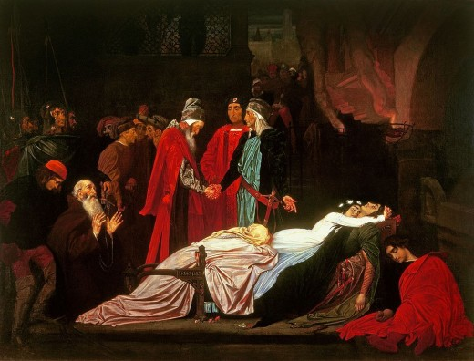

**学习资料：**

**https://owlcation.com/humanities/Romeo-and-Juliet-Prologue-Analysis-Line-by-Line**

**概要：**

**开场白是一首ABAB CDCD EFEF GG格律的抑扬五音格的十四行诗；**

**它通过暗示大部分情节来渲染剧本的场景；**

**在诗歌第一节的四行里，描述了场景设置和剧情的基本冲突；**

**接下来的四行诗节中，描述了年轻的恋人以及他们的困境；**

**第三节讲述了家庭恩怨最终如何以悲剧收场，并解释了该剧的主要内容**

**最后两行提醒观众，舞台上将会展现的更多精彩内容。**

**Summary**

**The prologue is a sonnet with 14 lines of iambic pentameter in an ABAB CDCD EFEF GG rhyme scheme**

**It sets the scene for the play by hinting at most of the action to come**

**It describes the setting and basic conflict in the first stanza of four lines**

**The next four-line stanza describes the young lovers and their dilemma**

**The third stanza tells how the family feud will finally end in tragedy, and explains the focus of the play**

**The last two lines remind the audience that there is more to come when the play is acted onstage**

**Prologue /'prəʊlɒg/**

**[noun] a speech, etc. at the beginning of a play, book or film/movie that introduces it. 序言；序幕；开场白 ——compare EPLOGUE 比照 收 场白**

**Chorus /'kɔːrəs/**

**[sing.] (especially in 16th century drama 尤指在16世纪的戏剧中)**

**an actor who speak the opening and the closing words of the play**

**(开场白和收场白的) 朗诵演员**

**household /'haʊshəʊld/**

**[noun] all the people living together in a house 一家人；家庭；同住一所房子的人**

**alike /ə'laɪk/**

**[adj.] [not before noun] very similar 相像；十分相似；compare unlike**

**My sister and I do not look alike. 我和我妹妹长得不像。**

**dignity /'dɪgnɪtɪ/**

**[noun] the face of being given honour and respect by people 尊贵；高贵；高尚**

**fair /feə/**

**BEAUTIFUL 美丽**

**(literary or old use) beautiful 美丽的**

**a fair maiden 美丽的少女；In fair Verona 在美丽的维罗纳**

**ACCEPTABLE/APPROPRIATE 可接受；恰当**

**acceptable and appropriate in a particular situation 合理的；恰当的； 适当的**

**a fair deal/wage/price/question 公平交易/合理的工资/公道的价格/恰当 的问题**

**scene**

**ancient**

**grudge**

**break to**

**mutiny**